ST. XAVIER’S COLLEGE

**(Affiliated to Tribhuvan University)**

Maitighar, Kathmandu



**Computer Graphics**

**Lab Assignment #8**

**Submitted by:**

Suman Malla

013BSCCSIT041

**Submitted to:**

|  |  |
| --- | --- |
| Er. Anil Sah  Lecturer, St. Xavier’s College |  |

**Date of Submission:-Tuesday, September 08, 2015**

**STATEMENT**

“Reflect any user given image about X axis and Y axis using C++ Builder”.

**SOURCE CODE**

#include <vcl\vcl.h>

#pragma hdrstop

#include "refl.h"

//---------------------------------------------------------------------------

#pragma resource "*.dfm"

TForm1 *Form1;

//---------------------------------------------------------------------------

__fastcall TForm1::TForm1(TComponent* Owner)

: TForm(Owner)

{

//Drawing Y axis

outPanel->Canvas->MoveTo((outPanel->Width)/2,0);

outPanel->Canvas->LineTo((outPanel->Width)/2,outPanel->Height);

//Drawing X axis

outPanel->Canvas->MoveTo(0,outPanel->Height/2);

outPanel->Canvas->LineTo(outPanel->Width,outPanel->Height/2);

}

//---------------------------------------------------------------------------

void __fastcall TForm1::reflectXClick(TObject *Sender)

{

int h,w,i,j,a,b,c,d;

int mx,my;

h=outPanel->Height;

w=outPanel->Width;

mx=w/2;

my=h/2;

for(i=0;i<=w;i++){

for(j=0;j<=h;j++){

a = -(i-mx)+mx;

b = j;

out1Panel->Canvas->Pixels[a][b] = outPanel->Canvas->Pixels[i][j];

}

}

//Drawing Y axis

out1Panel->Canvas->MoveTo((outPanel->Width)/2,0);

out1Panel->Canvas->LineTo((outPanel->Width)/2,outPanel->Height);

//Drawing X axis

out1Panel->Canvas->MoveTo(0,outPanel->Height/2);

out1Panel->Canvas->LineTo(outPanel->Width,outPanel->Height/2);

}

//---------------------------------------------------------------------------

void __fastcall TForm1::reflectYClick(TObject *Sender)

{

int h,w,i,j,a,b,c,d;

int mx,my;

h=outPanel->Height;

w=outPanel->Width;

mx=w/2;

my=h/2;

for(i=0;i<=w;i++){

for(j=0;j<=h;j++){

a = i;

b = -(j-my)+my;

out1Panel->Canvas->Pixels[a][b] = outPanel->Canvas->Pixels[i][j];

}

}

//Drawing Y axis

out1Panel->Canvas->MoveTo((outPanel->Width)/2,0);

out1Panel->Canvas->LineTo((outPanel->Width)/2,outPanel->Height);

//Drawing X axis

out1Panel->Canvas->MoveTo(0,outPanel->Height/2);

out1Panel->Canvas->LineTo(outPanel->Width,outPanel->Height/2);

}

//---------------------------------------------------------------------------

**OUTPUT**

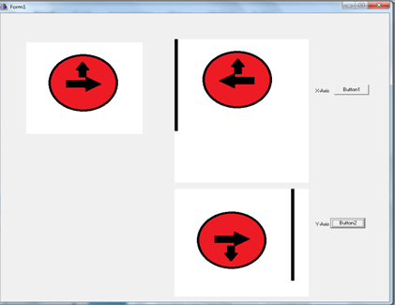

**CONCLUSION**

Thus, reflection about X-axis and Y axis is done using C++ builder.